DH-63
Horizontal Machining Center
Technical Agreement
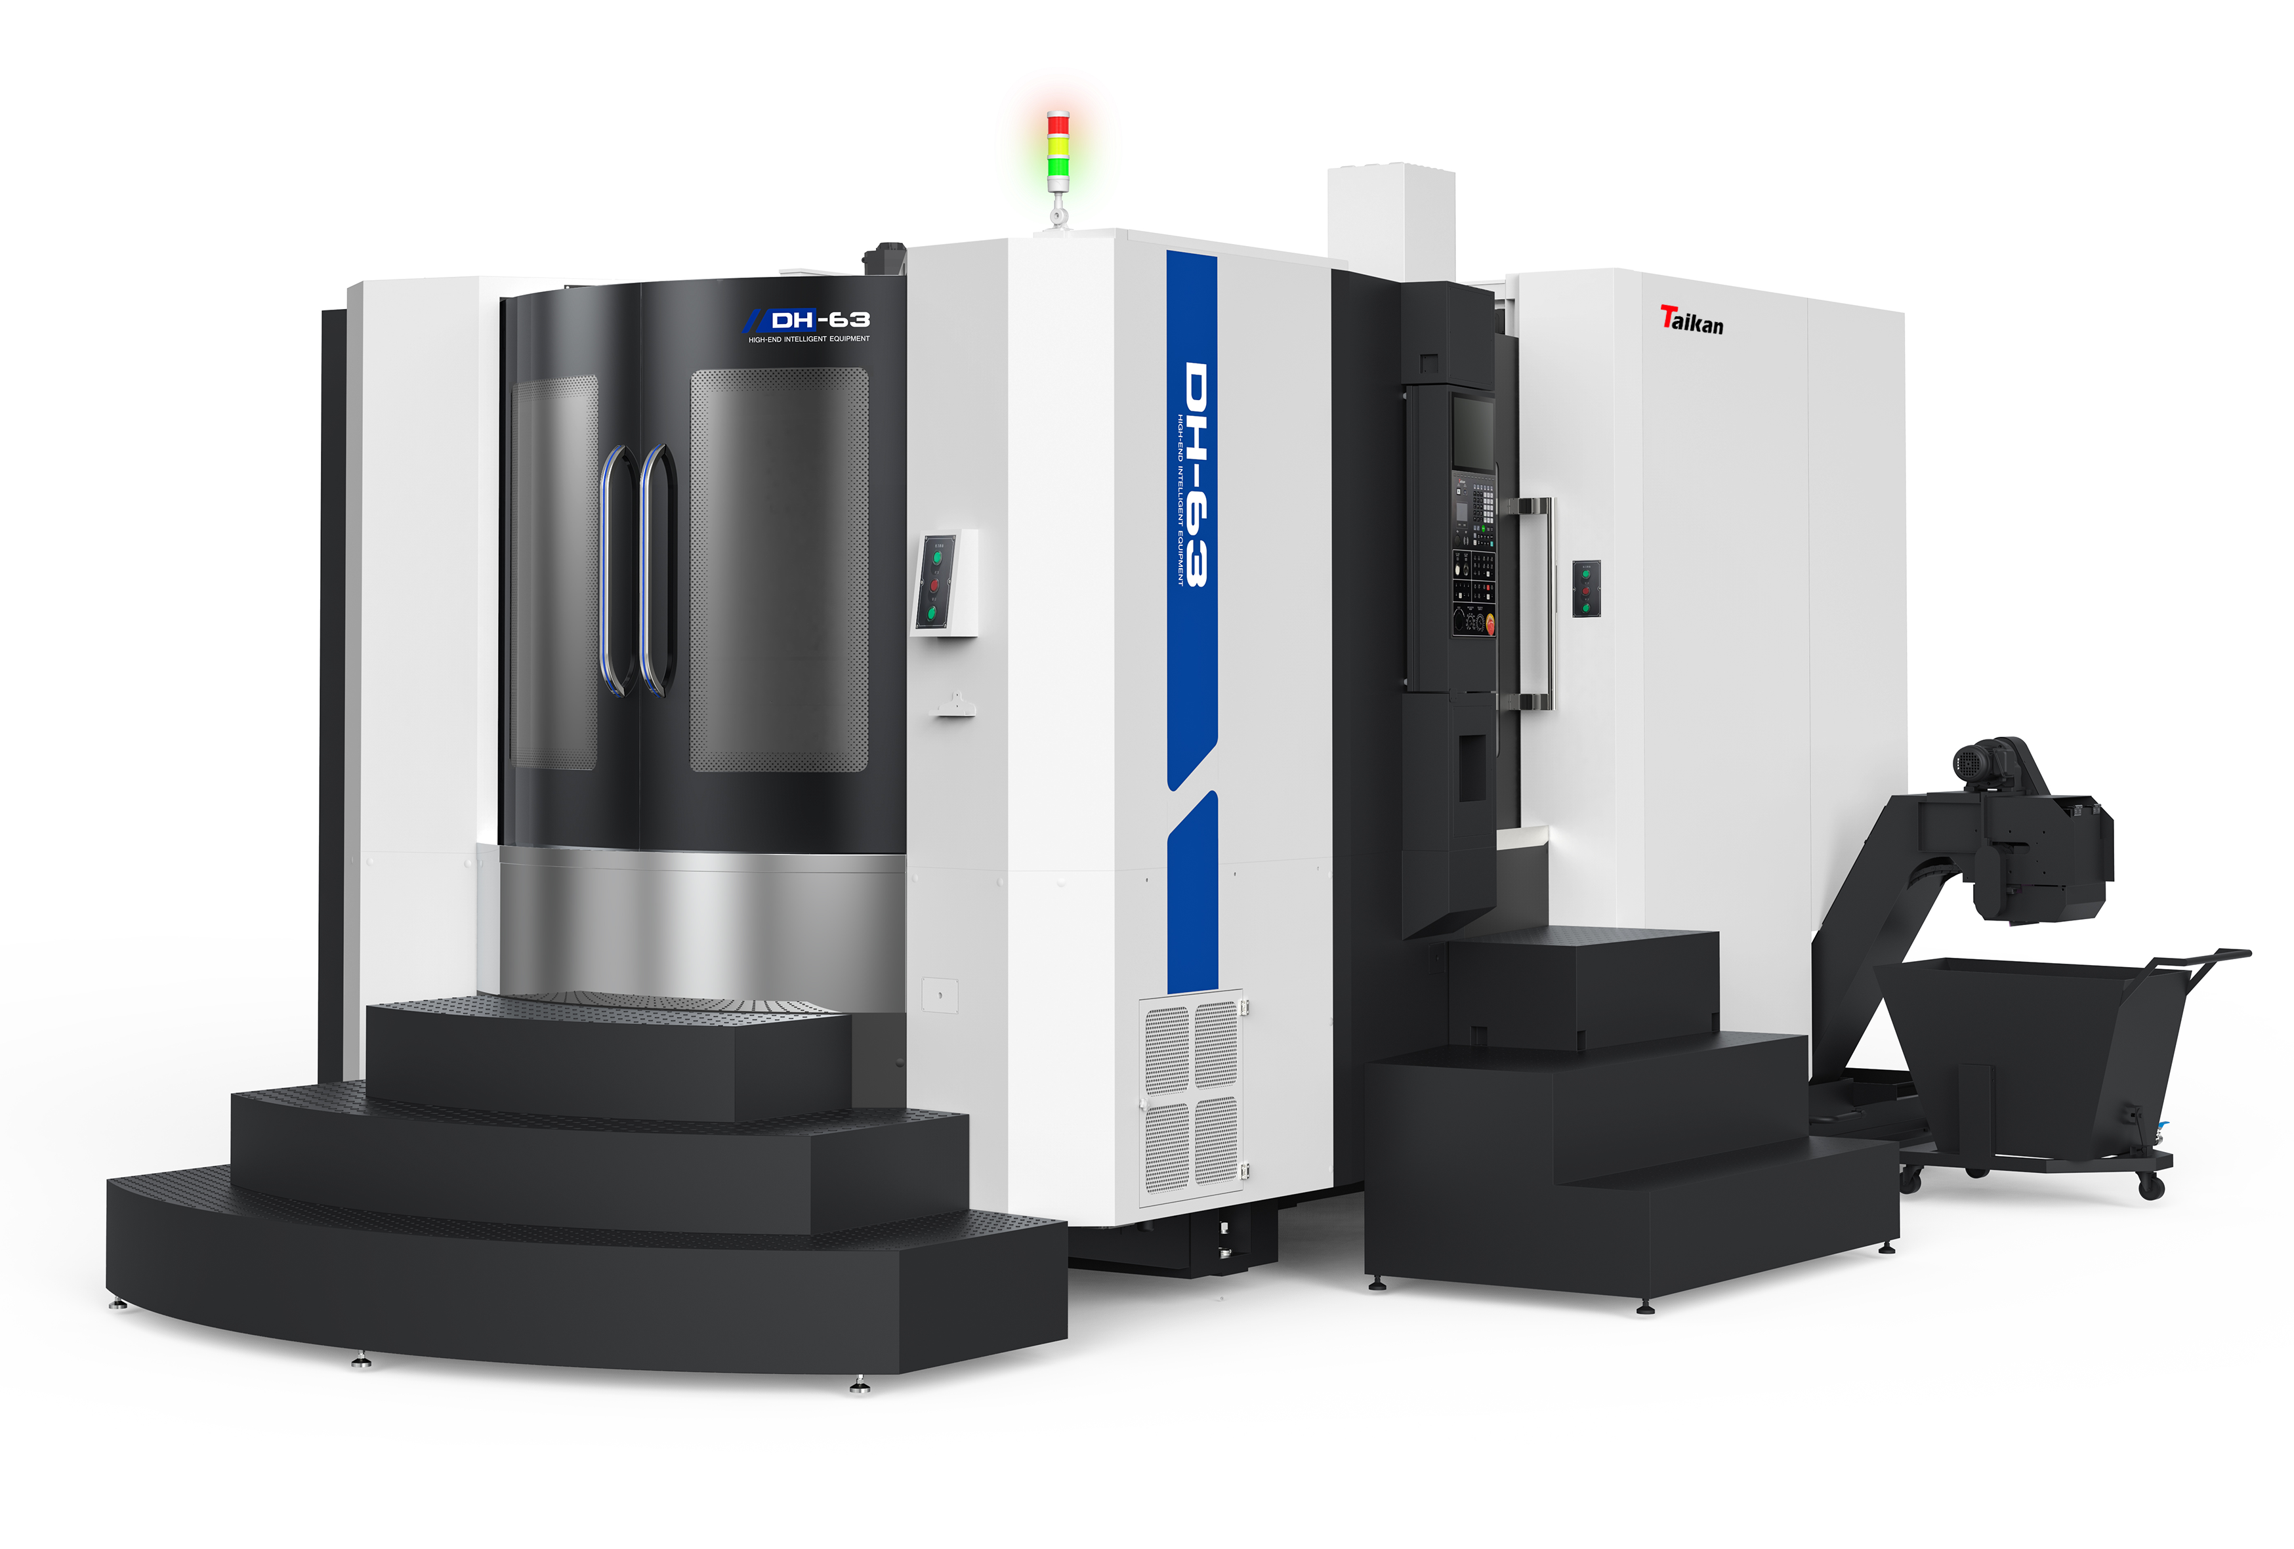
（This picture is for reference only）
- Technical descriptions:
DH-63 double exchange pallet horizontal machining center is mainly used in machining parts of construction machinery, automobile, energy, mold and other industries. It is suitable for the machining of box parts and shell parts, especially for the machining of complex special-shaped parts.
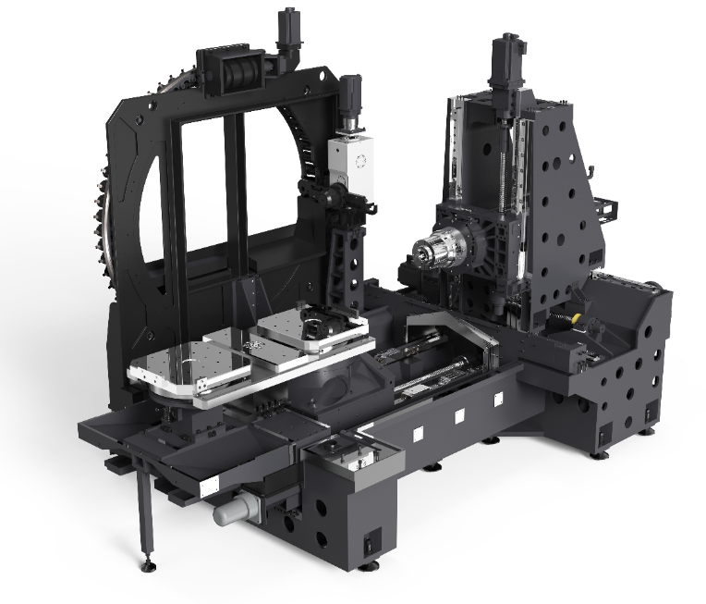
- It adopts a T-shaped structure, with the column moving left and right (X-axis), the spindle box moving up and down (Y-axis), and the worktable moving backward and forward (Z-axis).
- Combined with modern finite element analysis software to continuously optimize and improve the rigidity of the main structure of the bed to achieve the most optimal design.
- The three-axis ball screw adopts hollow cooling design, through the cooling unit to let the temperature-controlled coolant circulate in the axis of the screw, so as to rapidly cool the temperature rise of the ball screw during high-speed feeding, keep the temperature constant, and realize stable machining accuracy.
- DH-63 selects high-power BT50 motorized spindle with double windings switching automatically, which can realize different needs of high speed and high torque. High speed, high precision, low noise, fully meet the requirements of boring, milling and drilling processing. The spindle is equipped with constant temperature cooling system as standard, which improves the service life of bearings and reduces the impact of thermal deformation of the spindle on machining accuracy.
- Equipped with centralized automatic grease lubrication system to ensure good lubrication of all moving parts. Maintenance is simple and convenient, saving the environment.
- Equipped with high-performance Siemens 828D CNC system, all three axes are driven by Siemens 1FK motor, which ensures the stability of the machine control, and also ensures the numerical control machining functions and auxiliary functions required by users.
- Combined with industrial design elements and human-computer interaction considerations, the entire machine appearance and styling design is beautiful and neat, reasonable operating position layout to enhance the human-computer interaction experience.

- Equipment detailed parameters
Name |  |  | Unit | Parameter | Remark
Travel | X/Y/Z |  | mm | 1050/800/1000
Travel | Distance from spindle end face to worktable center |  | mm | 150-1150
Travel | Distance from the spindle to the worktable surface |  | mm | 120-920
Travel | Max. workpiece size |  | mm | φ1000×1000
Worktable | Size |  | mm | 630*630
Worktable | Max. load |  | kg | 1200
Worktable | Center hole size |  | mm | φ80H7
Worktable | Screw holes |  | mm | M16(125×125)
Worktable | Min. setting unit |  | ° | 0.001
Spindle | Power (S1/S6 15%) |  | kW | 28/42
Spindle | Torque (S1/S6 15%) |  | Nm | 334/630
Spindle | Speed |  | r/min | 10000
Spindle | Taper |  | - | BT50
Speed | Feed axis motor power |  | kW | 7.7/8.2/7.7/2.9
Speed | X, Y, Z axis rapid traverse |  | m/min | 48/48/48
Accuracy | Positioning accuracy (X/Y/Z) |  | mm | 0.01 (no grating)  0.006 (with grating) | VDI3441
Accuracy | Repeat positioning accuracy (X/Y/Z) |  | mm | 0.006 (no grating)  0.004 (with grating) | VDI3441
Accuracy | Positioning accuracy (B) |  | arcsec | 8 (with grating) | VDI3441
Accuracy | Repeat positioning accuracy (B) |  | arcsec | 6 (with grating) | VDI3441
Tool magazine | Capacity |  | T | 60
Tool magazine | Tool length |  | mm | 500
Tool magazine | Tool diameter |  | mm | 105/210
Tool magazine | Tool weight |  | kg | 20
other | System |  | - | Siemens 828D
other | Gas source | flow | L/min | 500 (ANR)
other | Gas source | pressure | MPa | 0.6∼0.8
other | Total electrical capacity |  | KVA | 75
other | Size (L*W*H) |  | mm | 6575×4870×3300
other | Total Weight |  | kg | 21500
#: The overall dimensions of the machine tool are subject to change due to configuration, without further notice.

- Equipment configuration list
- Main configuration
No. | Name and specification | Qty | remarks
1 | Cast iron body | 1 set
2 | Siemens 828D CNC system | 1 set
3 | Three-axis linear guide rail | 1 set
4 | Three-axis hollow ball screw (with cooling system) | 1 set
5 | Rotary worktable and exchange mechanism | 1 set | cam roller
6 | Rotary worktable direct measuring system (circular grating) | 1 set
7 | BT50 motorized spindle 8000rpm | 1 set
8 | 15 inch touch monitor | 1 set
9 | 60T disc-type tool magazine | 1 set
10 | Automatic lubrication system | 1 set
11 | Spindle cooling system | 1 set
12 | Tool cutting cooling system | 1 set
13 | Pneumatic circuit system | 1 set
14 | Full protective sheet metal cover | 1 set
15 | Electric cabinet air conditioner | 1 pcs
16 | LED work lights | 1 pcs
17 | Tri-color warning light | 1 set
18 | security door lock | 1 set
19 | External handwheel | 1 set
20 | Built-in screw chip conveyors + rear chain chip conveyors | 1 set
21 | Hydraulic station | 1 set
22 | Toolbox and tools | 1 set
23 | A set of machine tool maintenance and operation program instructions (electronic version) | 1 set

- Option list
Serial Number | Name and specifications | select | notes
1
2
3
4
5
6
7
Note: If this configuration is selected, mark √ in the corresponding item box

- Brand of main equipment component
NO. | Name and specifications | Brand | Remark
1 | System | Siemens | Germany
2 | Spindle unit | TAIKAN
3 | Rotary worktable and automatic exchanger | TAIKAN
4 | Ball screw | Yintai/Hiwin | Taiwan
5 | Screw bearing | FAG/ NSK | Germany/Japan
6 | Linear guide rail | Yintai/Hiwin | Taiwan
7 | Main pneumatic components | SMC | Japan
8 | Spindle cooling machine | Tongfei | China
9 | coupling | NBK/KTR | Germany/Japan
10 | Electrical cabinet air conditioning | Tongfei | China
11 | Main electrical components | Schneider | France

- Working conditions
1. Precautions:
This machine should be avoided to be placed in the following places:
1.1. Direct sunlight, close to heat sources and environments with huge temperature changes.
1.2 High humidity environment.
1.3 Dusty environment.
1.4 Environment with vibration source nearby.
1.5 Environment with soft foundation.
2. Requirements for the working environment (environmental conditions for stable operation of the machine tool):
2.1 Ambient Temperature: 5 ~ 40 ℃.
2.2. Relative humidity: ≤75%.
2.3. Power supply: 3AC380V ± 5%, 50Hz ± 1%.
2.4. Air medium: non-corrosive medium.
3. Environmental conditions for precision assurance:
3.1. The machine must be installed on an independent foundation base and away from the vibration source.
3.2. The ambient temperature is maintained between 22 ± 1 ℃.
3.3. Temperature change within 30 minutes ≤ 1 ℃.
3.4. Relative humidity ≤75%.
3.5 Dust particle density ≤ 0.3 mg/m3.
4. Air pressure source requirements:
4.1 Required air pressure is 0.6 ～ 0.8 MPa.
4.2. Air flow rate provided by the compressor: 500 L / min (ANR) without workpiece blowing chips.
4.3. Dew point temperature: below -17 °C or lower (atmospheric pressure environment).
4.4. Requirements for clean air with little moisture oil mist, do not use the compressor to supply air directly to the machine through a short tube, high temperature air in the machine cooling will make the oil viscous, clogging valves and pipes, leading to rust and burn spindle bearings.
4.5. When the air contains a lot of moisture to use desiccant or other auxiliary devices.
5. Coolant requirements:
5.1. The coolant must be water-soluble coolant.
5.2. The coolant must be chemically stable and lubricating.
5.3. Ensure that the coolant is not toxic to the human body.
5.4. Ensure that the coolant does not harden or swell items made of rubber and resin.
5.5. Use a low-foaming coolant.

- Others
- Matters not covered in this agreement shall be resolved through negotiation between the two parties.
- This agreement is an attachment of the contract, and it will take effect simultaneously with the contract after being signed by both parties.
- This agreement is made in duplicate, one for each party.

